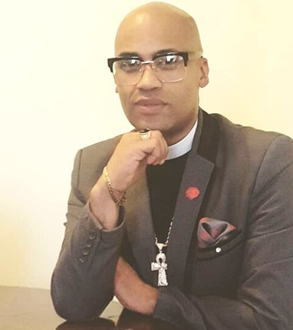
Short Biography: Rev. Morné E. Meyer
MDiv After having served African Methodism with honor in his home country, South Africa, the Rev. Morné E. Meyer is currently completing his Doctor of Ministry Degree at Payne Theological Seminary, the oldest freeStanding accredited black seminary in the United States and the Pride of the AME Church. Rev. M, as he is affectionately known, hails from Cape Town, South Africa. There, in the Mother City, he faithfully pastored churches for ten years before relocating to the United States in 2017. This vibrant preacher and speaker came through all the ranks of the African Methodist Episcopal Church from a very young age. Today, he is proudly flying the flag of African Methodism as the newly appointed pastor of the historic St. Paul, Columbus. Prior to this, he has built up a track record of success at 7 congregations in South Africa and 2 in the United States. In many of his previous assignments, he was tasked to rebuild, revive, and restore with great results to prove. With 15 years’ ordained ministry experience (+1 years as licentiate) , Rev. Meyer has proven to be a powerful administrator with an inclusive yet confident leadership style. Before embarking on his doctoral studies, he achieved a national certificate in business management, national diploma (associate degree) in public administration bachelor’s degree in theology followed by two Master’s degrees: one in ministry and another in divinity from Payne Theological Seminary. With solid management experience in the corporate world, he is also known as a hands-on, strategic planner. Before relocating to the United States, he was a communications and marketing manager overseeing five different college campuses with 10 000 students and 400 staff members at West Coast College and the owner and President of a PR, events, and catering company. Rev. Meyer is well-trained, fully equipped and prepared to serve. He has a particular interest in the ministry of restoration. Together with the people of St. Paul, he is ready to lead people to a renewed sense of hope that will inspire people to rebuild their lives and communities, and, ultimately, restore their faith in God.

